PD_TC _06 - OrangeHRM_Personal Details _Leave the Last Name Field blank

Launch the URL

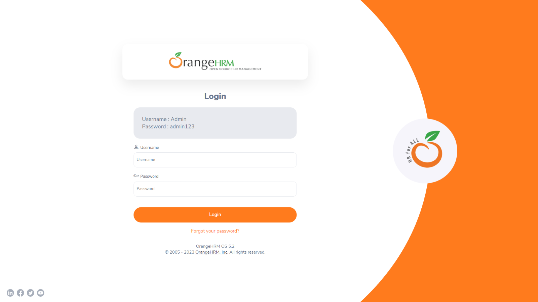

Login to the application with Valid credentials

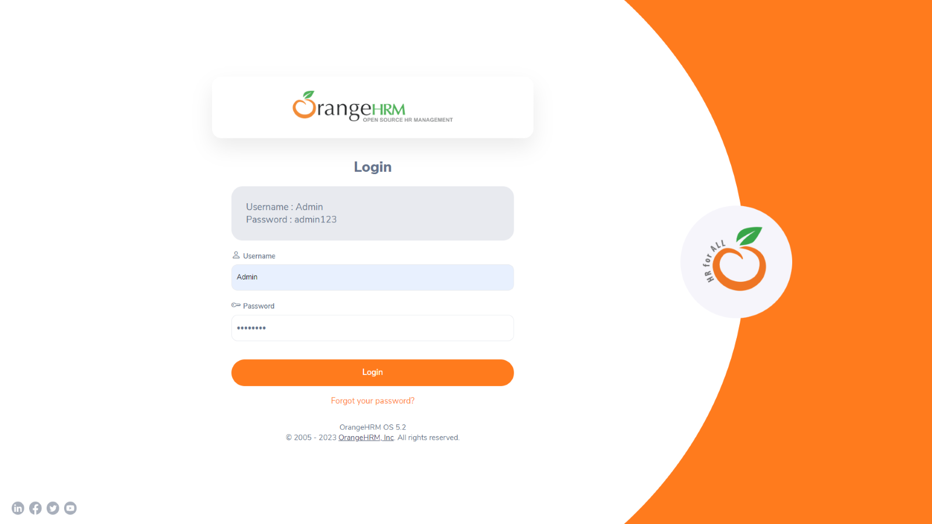

Logged successfully & navigated to personal details tab

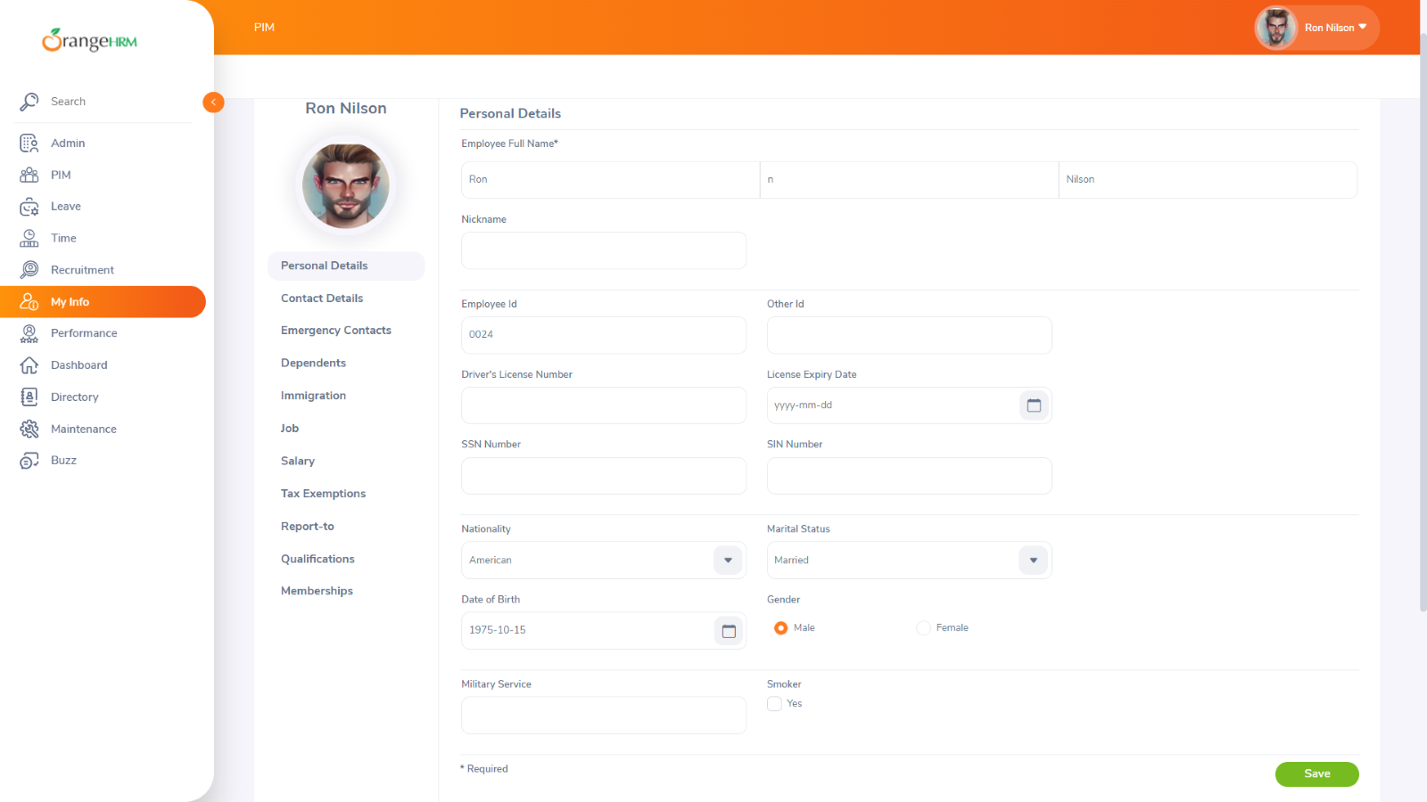  
Leave the last name field blank

